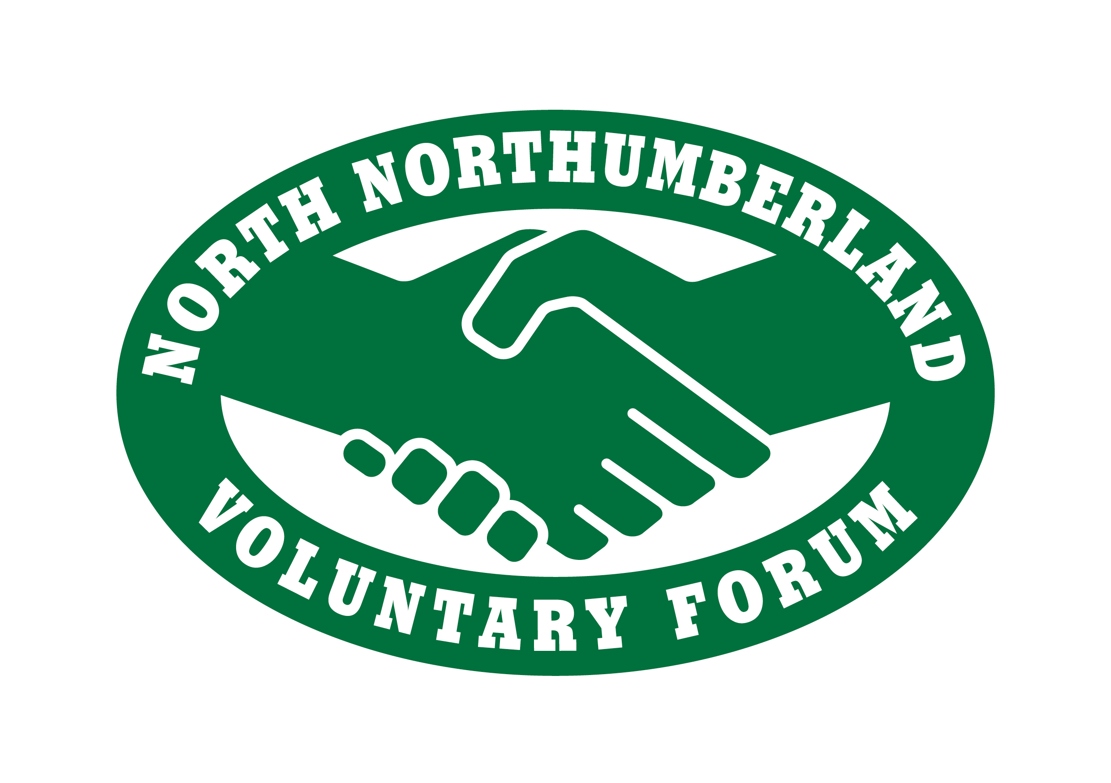
North Northumberland Voluntary Forum - Small Grants Opportunity Application Form
Applications are welcome to set up a new group or extend an existing one within North Northumberland. One off grant funding, usually up to £100, available from June 2017 until funds depleted. (Please read attached guidelines for restrictions)
Name of Project

How much are you bidding for ?
Aim or Purpose of your Group

Aim or purpose of this project

Named Contact:

Email Address:

Telephone: | Day:  Evening:
Address:

Postcode
Name, address & Telephone No. of  2 other members: | 1.
Name, address & Telephone No. of  2 other members: | 2.
Three things you hope to achieve: | 1.
Three things you hope to achieve: | 2.
Three things you hope to achieve: | 3.
Bank details:

Account Name:

Acct No.

Sort Code:

By signing this application, the named contact agrees to complete and return a feedback questionnaire, which will be supplied six months after receiving the funding.

Name: ............................................................ Date:....................................

Please return completed applications to North Northumberland Voluntary Forum either by email or by post:
bvforum@hotmail.co.uk

Postal Address:

Berwick Voluntary Centre, 5 Tweed Street, Berwick-upon-Tweed, TD15 1NG

Guidelines and application forms are also available on the NNVF website:
www.nnvforum.org.uk

Sponsored by:
North Northumberland Voluntary Forum (NNVF) and Northumberland County Council

